**Recertification (Renewal) Certification Process 11-2017**

Run the Medicaid Provider Report (link provided by S. Darby) <https://reports.dhss.alaska.gov/Reports/Pages/Report.aspx?ItemPath=%2fDSDS%2fProviders%2fMedicaid_Provider_Certification_Application_and_Expiration&ViewMode=Detail> → Enter Cert End Date From & End Date To (this is the certification month)

**Report Criteria**:

Start date (1st of mo.) & End date (end of mo.)

Enter Status: Active, & Inactive - Cert Enrollment Pending

View Report and export to excel

**Excel**

Once report is generated you will need to modify using the following instructions:

1. Ctrl + Shift, use right arrow to column “U” and select down arrow once
2. Insert → Table → select my table has headers
3. Remove all hyperlinks – Select Colum “A”, right click and select “remove hyperlinks.”
4. Unhide extra columns & Delete them to include Full Mailing (C,E,F,H, & I)
5. Med Code → Sort from ‘Z’ to ‘A’ and delete all GR
   * GR # is Alpha Numeric
   * Providers to keep: RLX, HCX, EMX, CMGX, CMX & PCG or PCSX
6. Med Code End Date → Sort new to oldest and delete all except current month. *out of state provider; check against DS3 for waiver services, and with Jen to see if she has sent notices.
7. Application Received Date sort Oldest to Newest
8. Review all other columns for newest dates not Medicaid State Date.
   * Should review Medicaid End Date, and any new application dates to determine what has been received, and then delete them. It is advised to highlight any provider who have NOT submitted a new app.

**Before Merging you must follow these steps for 1st Notice:**

Of Note: you must enter a space then spell out the month or it will not merge correctly.

1. Enter End Date, Due Date, & Sent Date.
2. Follow all six steps noted in the Merge Wizard.

**Follow these steps for Final Notice:**

1. Enter Was Due, Now Due & Send Date columns.
2. Save report here: g:drive→ Provider Certification Letter and Notices → Re-Certification Letters & Labels → Source Spreadsheets. Open current year’s folder and save as Excel .xlsx in the month renewal is due using the following format for file name: Month and 1st or 2nd Recertification notice. For example: February 1st Recertification Notice

**Word**

**Once you have modified your report the following steps should be taken in MS Word to generate the Recertification (renewal) notices:**

1. Access the Recertification notice and envelope folder to gain access to notice and envelopes: g:drive → Re-Certification Letters & Labels →
2. Access the Recertification Letter dated 9-1-17 Or Final Notice Template
3. Select ‘Start Mail Merge’ and from drop down select “Step-by-Step Mail Merge Wizard”

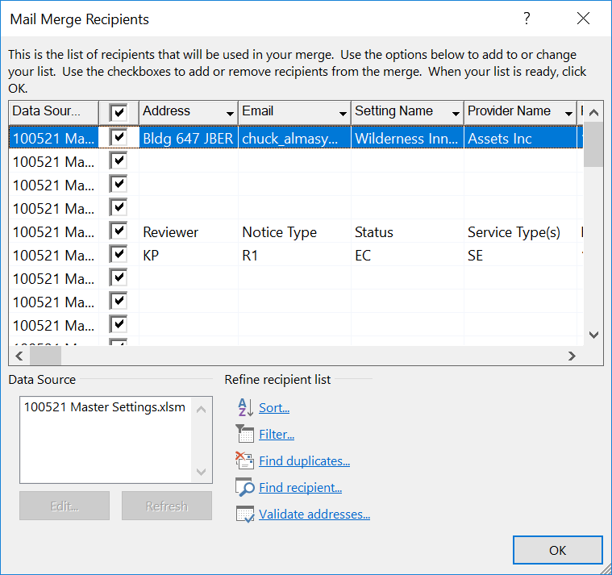

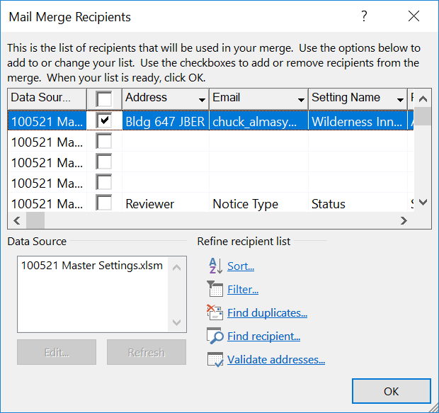

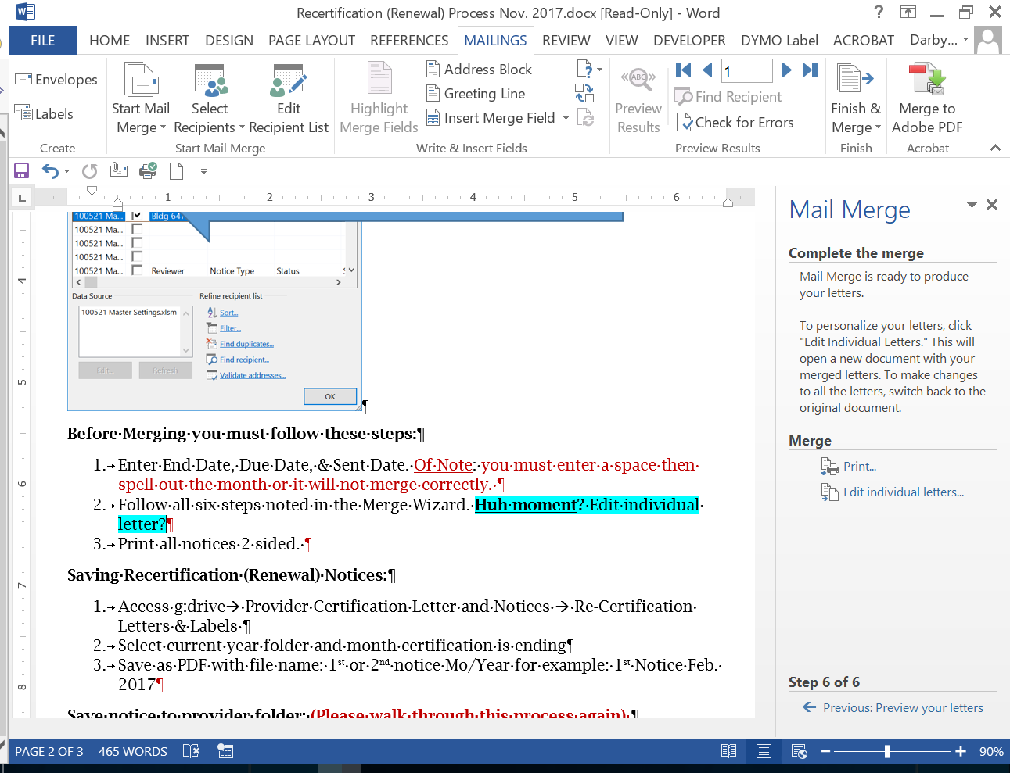

1. Print all notices 2 sided. (Final notices are one sided)

**Saving Recertification (Renewal) Notices:**

1. Access g:drive→ Provider Certification Letter and Notices → Re-Certification Letters & Labels
2. Select current year folder and month certification is ending
3. Save as DocX and PDF with file name: 1st or 2nd notice Mo/Year for example: 1st Notice Feb. 2017 or Final notice 1-31-18

**Adobe**

**In Adobe, to be able to Save notice to Provider Agency folder:**

Select and delete all bookmarks → Open left side bar to view any bookmarks and delete.

Create new bookmark to split files to be saved in provider folders.

1. Highlight Provider and Enrollment number & repeat this for all letters
2. Select Control ‘B’ – Do this for all letters
3. Organize pages → select ‘split’
4. *Split by top level bookmarks from drop down*
5. Select ‘gear’ for output options
6. Select bookmark names for file names → OK
7. Split and generate in renewal folder
8. Drag to Provider Folder

**Creating Envelopes:**

1. User same spreadsheet used for mail merge notices
2. Mail Merge wizard → Sept one: Select document Envelopes
3. Follow wizard instructions
4. Finish and Merge and then save as PDF

**DS3 notes**

For each provider enter a note that a first notice/final was sent on xx-xx-xxxx date

Questions for Cheri:

1. Is there a possibility to email these to providers?